Invitation

Email Subject Line: Help define the future of [INSERT ORGANZATION NAME]!

Hi _______,
You’re busy, I get it, so I’m going to cut to the chase.

As you know, we’re refreshing our space/building soon. To make sure we maximize the opportunity before us, we need creative and strategic minds like yours in a design and dream workshop ran by our architectural firm, Visioneering Studios.

Now, before you start picturing this…. It’s actually more like this…

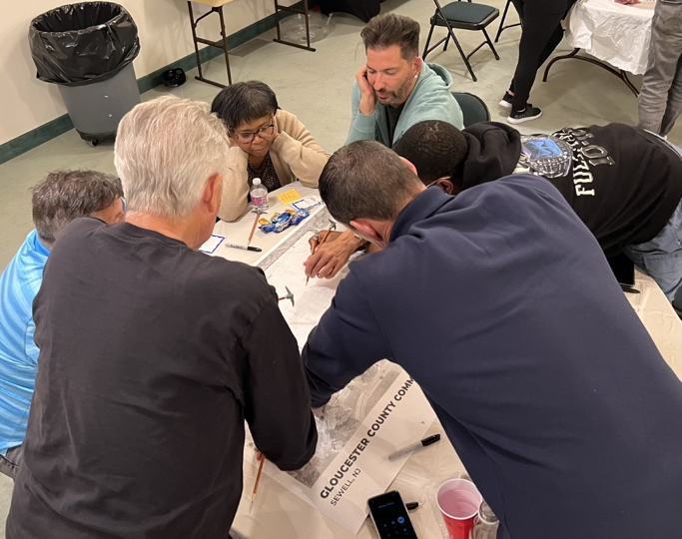

The session is called Basecamp, and the Visioneering team describes it as “imagine if a focus group and a brainstorm session had a baby.” Sounds fun, right?

We hope you’ll join us for this important first step in shaping the future of [INSERT ORGANZATION NAME]!

Here are the details:
• Date: ___________
• Time: 6-8:30pm (Dinner provided)
• Please RSVP to ___________

Let me know if you have any questions. See you at Basecamp!
[Sender name]

